
PROFILE

HSE Professional with over 19 years of experience in the UAE, specializing in general construction, fit-out, and infrastructure projects. Extensive background working with both main contractors and specialist subcontractors, ensuring compliance with local and international safety standards. Experienced in the transport sector, with expertise in heavy earth moving operations and specialized lifting activities, delivering safe, efficient, and compliant project execution.

EDUCATION
BS Computer Science – University of Perpetual Help System, Laguna (1998–2002)

PROFESSIONAL MEMBERSHIP
Philippine Society of Safety Professionals (PSSP), Dubai – Member

DIGITAL SKILLS
- HSE Digital Tools: SharePoint, Microsoft Teams Integration
- Data & Office Tools: Power BI, Advanced Excel(Dashboards, Data Analysis, Visualization)
- Design & Media Tools: Adobe Photoshop, Illustrator, Premiere Pro, Audition, Canva
- Marketing Tools: Facebook Ads, Social Media Content Creation

CERTIFICATIONS

 | NEBOSH International General Certificate  February 2013 (4 Weeks)  Aspire Training Institute
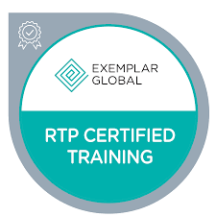 | ISO LEAD AUDITOR  ISO 45001:2018 Quality Management Systems  ISO 14001:2015 Environmental Management Systems  ISO 9001:2015 Quality Management Systems
 | IOSH Managing Safely  Dec. 17-20, 2006  Corporate Health and Safety Solutions – Jumeirah Rotana Hotel, Dubai
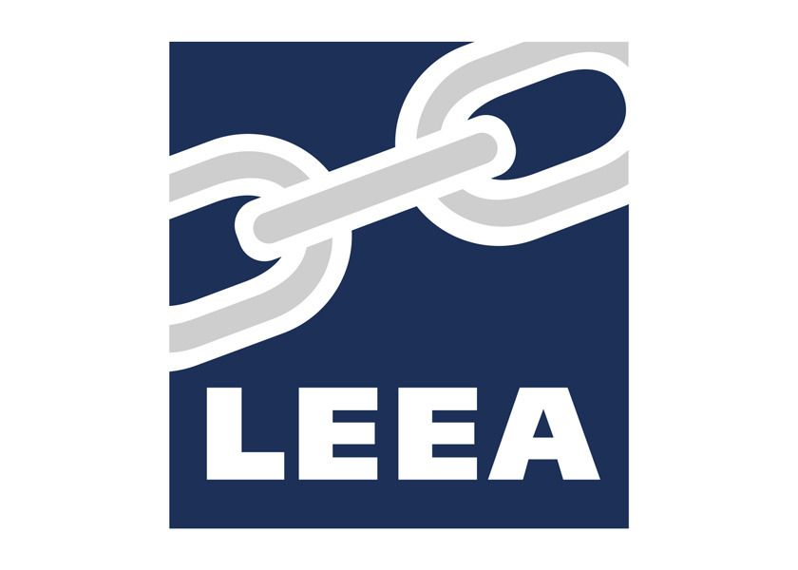 | LEEA Appointed Person for Lifting Operations,  Aug. 18-22, 2022  Arbrit Safety & Engineering Solutions
 | SARS Certification,  April 16, 2008  Registered Safety Advisor – Trakhees
 | Highfield Level 3 First Aid,  CPR & AED  August 14-16, 2025
 | Health, Safety, and Environmental  (HSE) Engineering Specialization  Khalifa University, Online Program, 2025

ADDITIONAL TRAINING
(On going) 192 hrs - Construction Safety and Health Professional Program

Includes certifications as:
- Construction Safety and Health Manager (162 hrs)
- Construction Site Safety Supervisor (145 hrs)
- Construction Safety and Health Specialist (130 hrs)
- Train-the-Trainer (47 hrs)

 | Construction Site Electrical System Design (2025)  Site Electrical Systems & Circuits, Electrical Grounding & Residual Current Devices (RCDs), Electrical Faults & System Sizing, Electrical Cabling & Installation Safety, Lock & Tag Systems for Hazard Control
 | Basic First Aid,  May 10, 2012  Aspire Training Institue
 | Scaffolding Inspection  May 19, 2012  Aspire Training Institue
 | Fire Fighting  Nov. 4, 2007  PCFC Fire Fighting Technical Department, EHS-JAFZA,
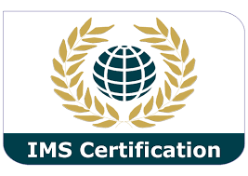 | Quality Manager Training ISO 9001-2008  October 26, 2011  IMS Certification DAFZA
 | Internal Audit Training ISO 9001:2008, OHSAS 18001:2007  November 23, 2011  IMS Certification DAFZA
 | Internal Auditor Training – OHSAS 18001:2007  December 5-6, 2008  TUV Noord – Jumeirah Rotana Hotel, Dubai
 | Environmental Management System ISO 14001:2004  September 26, 2008  TUV Noord – Cassells Hotel, Ghantoot Dubai, Dubai

CAREER SUMMARY
Sr. HSE Officer  (Functioning as Lead HSE Across Every Project)  2019– Up to present  ARCO Turnkey Solutions Cont. LLC. Dubai Investment Park 2 |   - LOC, Abu Dhabi  Client: Sanad Gencon: Besix  - One Zaabeel Tower  - O Beach, Al Habtoor Grand Resort, Dubai Marina  Bluewaters  Client: Meraas  EXPO 2020  The Gardens – Jebel Ali  Client: Nakheel, Consultant: Mirage  City Walk – Redevelopment of Bldg. B3 & B6  Client: Meraaz, Consultant: North 25  M4 Redevelopment (The Beach) – Jumeirah Beach Residence  Client: Meraaz, Consultant: North 25  Duja Tower Recladding and Rectification of Fire Affected Apartments  Client: Lootah, Consultant: NEB  Torch Tower 3 – Recladding, Dubai Marina  Client: Torch Tower Owner’s Association, Consultant: NEB
HSE MANAGER  2019  Sama Al Patra Building Contracting, Dubai, UAE. |   Al Waha School  Client: Ministry Of Education, Consultant: Selbar
HSE MANAGER  2018-2019  Geoharbour Middle East | - Mohammed Bin Rasheed Al Maktoum Solar Park    Noor Energy 1-700MW CSP Project  Client: Noor Energy, Shanghai Electric
SENIOR HSE OFFICER  2016-2018  ARCO Turnkey Solutions Cont. LLC. Dubai Investment Park 2 |   Torch Tower 1  Recladding and Rectification of Fire Affected Apartments  Client: Torch Tower Owner’s Association, Consultant: NEB
HSE MANAGER  2012-2016  Al Rashid Group |   Emirates Steel Industries – Abu Dhabi  2012-2016
HSE ADVISOR  2007-2012  Construction and Reconstruction Engineering Company - DORRA Group/ Dubai, UAE | 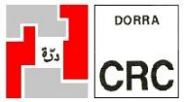  Al Mahawi Military Camp  7 Buildings Ground + 7 floors, 10 Storage yard,  Military school G + 2 floors,  General Head Quarters Building G+ Roof,  Meeting Hall, Play Yard, Swimming Pool,Basketball and Lawn tennis  Client: Command of Military Works, Abu Dhabi  Jumeirah Plaza Residence–2 towers 10 floors and 1 tower 16 floors, 3 Basement Upper Ground. Plot # JVC13AMRH200 Jumeirah Village Circle, Jebel Ali  Client: Cayan, Consultant: NEB

Dome Tower at Jumeirah Lake Towers – 3 Basement + 41 floors Towers Plot # N1/

Client: Al Serkal, Consultant: DEC

Arbift Tower – 3 Basement + 31 Floors, Dubai Marina Plot # 392-433 Client: Al Mashraf, Consultant: Hegazy

Silverene Tower– 3 Basement + 32 Floors - Enabling Works, Dubai Marina Plot # 3AB

Client: Cayan, Consultant: RMJM
HSE Officer  2006-2007  JC Maclean International | 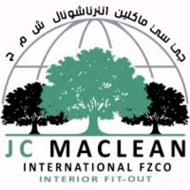  The Palm Jumeirah – Shoreline Apartments  The Avenues  (The Largest Shopping Mall in Kuwait Project)

DUTIES AND RESPONSIBILITIES

- Implements the project safety plan including emergency action plan if required, and conducts safety awareness training for company and subcontractors personnel in compliance with statutory requirements, government and/or local regulations.
- Conducts daily inspections of the work and processes to ensure safe working practices.
- Develops and implements a documented system of penalties for persistent safety violations by individuals.
- Develops and implements a system for issue of a “stop work order” where items of work are profoundly unsafe.
- Ensures good housekeeping at all locations, cleanliness, and tidiness. (Workshops, site surrounds.)
- Identify, eliminate/minimize fire hazards including gas cylinders and other flammable products are safely stored.
- Endeavor to resolve safety issues at site level with PM/SE for resolution, when cannot be resolved at site levels refer maters to GM.
- Ensure firefighting, safety equipment is available and used where hazards dictate and that first aid equipment is readily available where required.
- Ensure mechanical equipment is in safe working order including slings be controlled as per work instructions, and lifting equipment certificates are valid, including qualified operators.
- Ensure electrical equipment is correctly rated, grounded, and cables in good order with suitably plugged and proper accessories.
- Develop and implement a system to ensure scaffolding, formwork, and any other construction equipment is safe, and prevent use of such scaffolding being under construction.
- Conducts regular meetings with Company and subcontractors staff and assess effectiveness.
- Prepare daily, monthly safety reports, determine areas of deficiency conduct risk assessment report and submit to PM, QAM, and site staff.
- Investigate accidents and prepare reports to PM, and recommend preventive actions to avoid recurrence.
- Develops and maintains a statistical system of NCR, and site accident registers to pinpoint critical safety areas in a project/activity to improve the company safety system.

